3d Modelling Assignment
-Stephen Delicata

Task 0 – Research & Theory

A.

Mocap Plugin

Mocap Plugin is the process in which live action is translated into on screen animation. It allows body movement to be translated on to screen. The way to archive this is to use animation nods on your character and match them with your body nods.
The virtual effects one can achieve are a simplest form of video animation. Similar to certain films life the Pirates of the Caribbean or the new Ninja Turtles, one can have an animation of himself moving and place it in a video footage. However, I still haven't seen a film video that applies the technique. The motion capture control doesn’t seen on acknowledge moving video, meaning that camera movement is limited to keep the illusion.
The future of Mocap could improve VFX effects by being a cheap way for animate, but until the camera can place the character at a correct angle the effects are limited with live video footage. [1]
Richoh Theta
Richoh Theta is the process of producing virtual reality photography. What this basically means is that any photo taken will have a 360 view of all of its surroundings. This means that every frame of the video will have a 360 degree view.
This technology allows user to virtually turn around and see the place from all angles. How this works that interior software takes images of the surrounding area at the same time. The images are then put together and with software to smooth the lines, it combines it into one image. This process also works with video as it grabs four images and combines them into one frame. While it may seem a bit stiff with movement, it gives all the angles by frame.
The future of Richoh Theta could improve VFX effects by concentrating on certain angles. When the virtual effect takes place, the character moves accordingly. The character would stay in the same position rather than move with the camera. If he is on the left side, he stays on the left side. [2]
B.

Mocap Plugin
Mocap plugin seems to have a future in film scenes. An artistic style one can pull is to have real life footage playing in the background, while live actions with dots(who will later be replaced by animated characters) move through the footage. The Mocap catches them and they are transformed into animated characters. After some editing, the characters take the actor’s position. Rather than stay in a green screen room, you get to film on location.
Richoh Theta
Richoh Theta technique seems to indicate a teaching simulations tool. For example the player can explore around the real live are and interact with objects. Similar to A.I., the video will be exploding with activity. For example, if you are investigating a piece of wood, a description will appear. When a person in the video comes and takes it, the description disappears and can only reappear if you get close to it.
C.

Mocap Plugin
Mocap Plugin would have society by increase the speed of product. Animating would not take as much time. This could al so be a cheap method to produce. Another use could be photography. Should you want to take a particular picture but wish to change your appearance. Another use could be in line with scaling. Architects can use this program for measurement.
Richoh Theta
As stated before, Richoh Theta could be used as an alternate form of education. One can learn without the need of a teacher by just using this process. This could also be a more reliable form of Google maps. Rather than guess the path you need to take, the program could take your location and allow you to travel around your destination. Giving you a clear indication of where you need to go and new locations you never even known about.

D.
LYNX - Camera Motion Control
Developed by Cinetics, the LYNX is a camera that is big in motion control. The camera can be used for the tasks of animation, panoramic photography and most importantly, Visual Effects. LYNX can be used to time lapse footage and can move thanks to its slider and directional motor control system. The LYNX comes equipped with certain tools, such as the LYNX Base Slider, LYNX Monetized Slider and LYNX 3 Axis Slider. The way it work is that you either control it from your phone or you set it to move to your own leisure.(One – twenty-four hours.) On Kickstarter, they have reach their goal.
SKYWATCH: a sci-fi short
The second project is a film where visual effects are the prime motive. SKYWATCH grabs many animator from around the world and brings them together to work of this one particulate film. The program they use is called Blender a free to download but useful item. This project VFX designers are all volunteers, but they simply cannot do it alone. On Kickstarter, they have opened up a page for the FILM with a request for funding. The money will hire full time VFX effects workers. As of recent, their goal has been reached and exceeded beyond that.

Task 1 – Storyboard
...

Task 2 – Preparing your 3D model
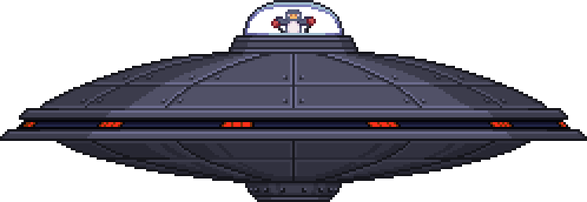
Mirror
Since the space ship is perfectly rounded, it does not make much sense to create it bit by bit. I will use a mirror to create one side and copy it on the other. This saves time and effort.

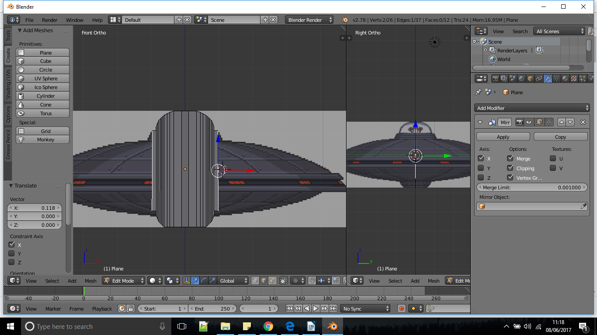
Subdivide Surface
I used a subdivide Surface to smooth it out. Removing its blocky interior.
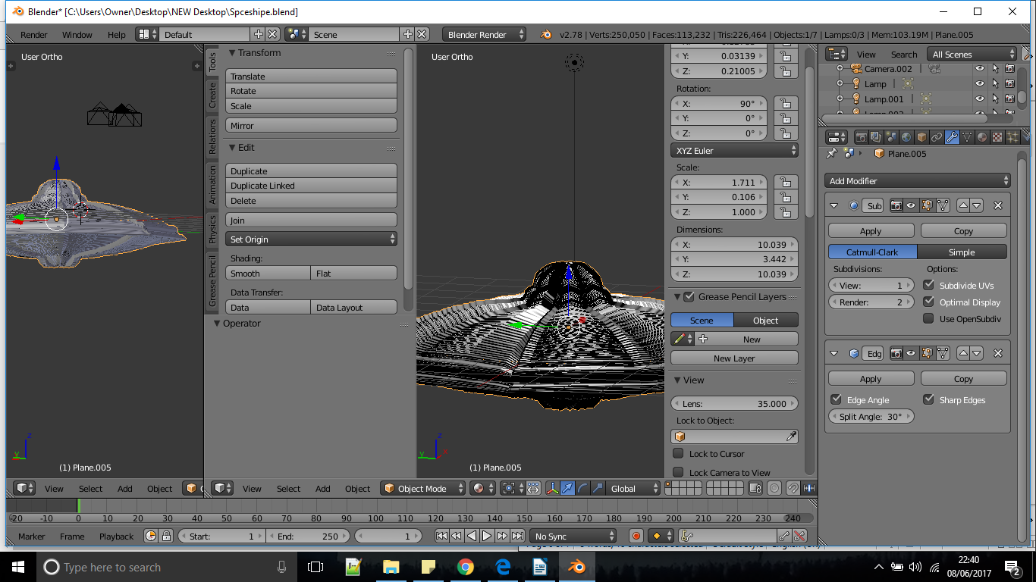
Edge Split
Since the subdivide surface made the space ship moor smooth, it also made it more jumbled. To fix this, I added an Edge Split to keep it smooth and removing the lines, while its cluster shape is removed.
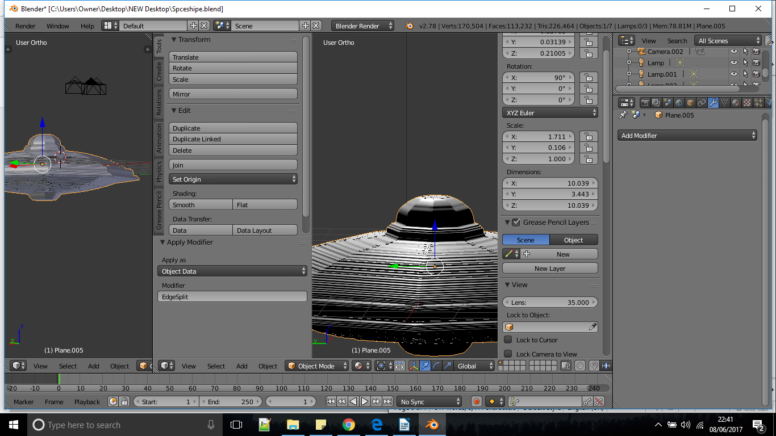

Edge Split
- Glossy
- Mix Shader
- Image Texture
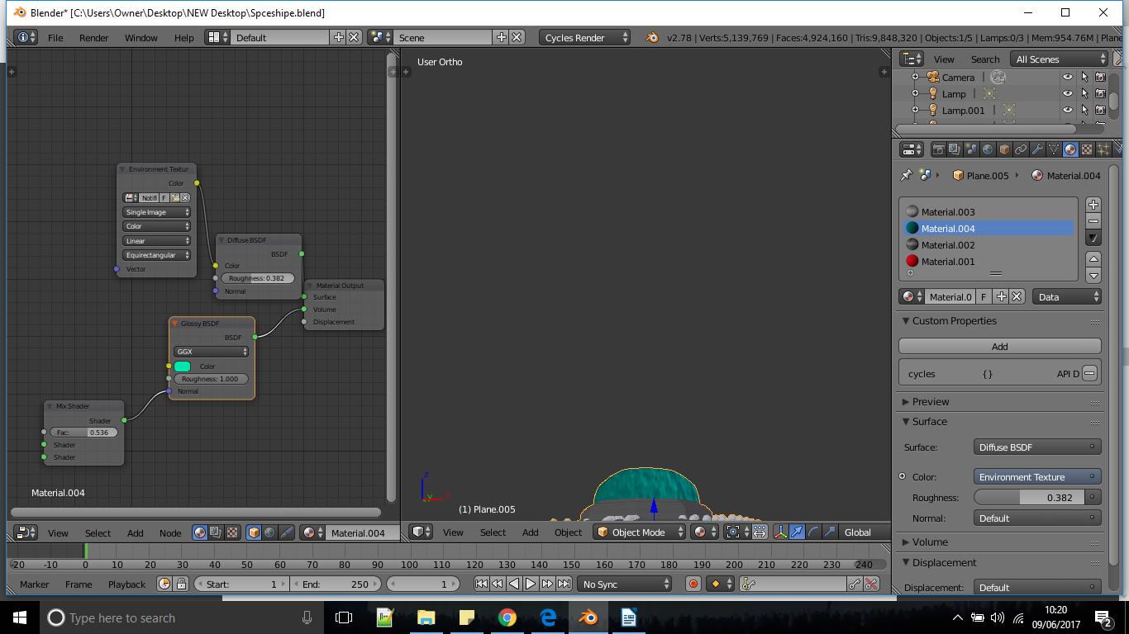

Task 3 – Setting up the scene

RBG Curves
In order to give it the more realistic look, I used RBG curves to change the lighting appearance.
Blender – cc2

Volume Absorption
In order to give it the colour of the Sea, I placed a volume Absorption attached to a shader.
Blender – Oceon

Transparent BSDF
In order to remove the background off my images, I used a Transparent BSDF to remove the black.
Blender - Oceon

Emission
I used an Emission to make the treasure glow.
Blender - Oceon

Task 4 – Adding Visual Effect
Animating Text
After an Alien looks around, the texts starts to turn and appear with
The phrase in the end.

Distorting Objects with ‘Puppet’ tool
The Beginning shows an alien looking around, the puppet tool gave that appearance.

Effects
A laser was shown blasting at the building before ending the scene.

Advanced Keying
I used a keylight to remove the aliens background.

Task 5 – Virtual Reality
Links:
Original Animation
https://www.youtube.com/watch?v=o3iHm5QIXq8&feature=youtu.be
360*
https://www.youtube.com/watch?v=S5lo-B9EOzA

References
1. https://www.unrealengine.com/marketplace/shadow-mocap-plugin
2. https://www.youtube.com/watch?v=XLw2vpxwNjU
3.https://www.kickstarter.com/projects/jj1/lynx-camera-motion-control/description
4.https://www.kickstarter.com/projects/colinlevy/skywatch-a-sci-fi-short

